****SMART MONITORING SYSTEMS FOR AUTONOMOUS VEHICLES USING IOT****

**INTRODUCTION**

Autonomous vehicles are a giant leap in technological advancement in transportation-a leader in transportation and a modern application of AI, machine learning, and sensory data to drive unaided by humans. The capability of IoT, Internet of Things allowed AVs to monitor and analyze real-time environmental data close to safety, efficiency, and adaptability.

Monitoring systems would typically form the backbone of autonomous vehicles wherein real-time observation for vehicle health, surrounding objects, and road conditions are possible. IoT allows these monitoring capabilities to be fully integrated into the system, and AVs can respond rapidly in dynamic environments.

**The fast pace of progress in self-driving cars has truly changed the way people get around, making the roads safer, more efficient, and friendlier. One of the most important things that makes AVs safe and reliable is that they can connect to the Internet.These cover and go over IoT systems. It goes over how smart tracking systems that use the Internet of Things (IoT) work.**

**They can make self-driving cars safer, better, and more useful all around. By putting together different sensors like *cameras*, *radar*, *LiDAR*, and transmission units, and the *Internet of Things* (IoT) helps AVs see what's going on around them, find obstacles, and make decisions based on facts.**

**Next, V2V_(Vehicle_to_Vehicle)and V2I_(Vehicle_to_Infrastructure),With the help of gadgets that let them talk, AVs can talk to other cars and traffic in real time.A system that keeps traffic moving easily and lowers the risk of an accident. In this we will talk about how IoT can be used to avoid accidents, make driving more adaptable, and make predictions.Mostly by how these changes are good for maintenance and system stability overall,A transport method that works better and is safer.**

**Smart mobility has taken a gigantic leap especially in the last few years of IoT converging with autonomous vehicles. While giving a cutting-edge benefit of more intelligence, efficiency, and less hazardous transport solutions, IoT lets systems interconnected exchange data seamlessly in ways which the internet steps up to produce much more. Highly dependent on the IoT with real-time decision-making, autonomous vehicles enhance operational efficiency. The introduction of IoT has revolutionized the way automobiles perceive, process, and respond to their surroundings as autonomous systems.**

**Such intelligent monitoring systems in autonomous vehicles cannot be overemphasized because they can maximally perform based on the intelligence of parameters set, including recognition of patterns in traffic, weather conditions, and internal diagnostics. Such is advisable with the use of IoT to enhance its capability for safe and reliable operation and minimal interference from human input.**

**Still, its integration into autonomous vehicles poses a lot of challenges. Some of the major ones include security risks in transferring data, considerable latency in communication, and the raw amount of information that sensors produce. Despite these challenges, though, the merits seem to highly outweigh the demerits, making IoT an essential constituent part of the future automotive industry.**

**The seminar report delves into why IoT is such an enabling factor in the context of autonomous vehicles, focusing on the design and application of smart monitoring systems. It articulates the technologies that make those systems functional, discusses the practical applications of such technology, and examins the actual implementation challenges.**

**COMPONENTS OF THE STUDY**

* **IoT Sensors in Autonomous Vehicles**
* Technologies for Data Processing and Communication
* Algorithms and Software Systems

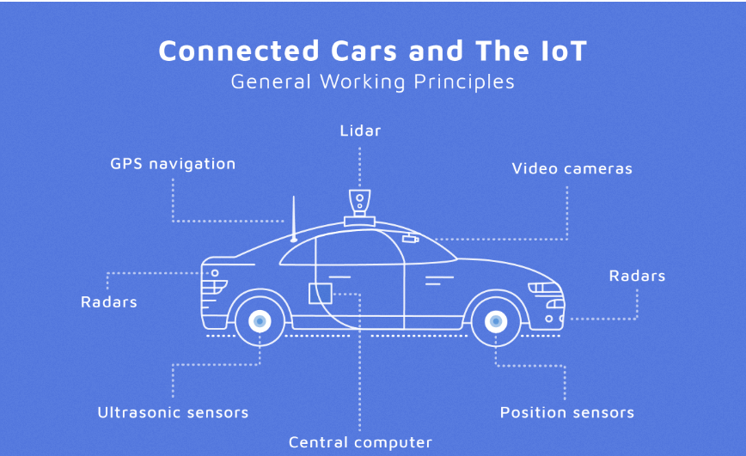

**INTERPRETATION OF THE CASE**

**Iot Sensors In Autonomous Vehicle**

Autonomous vehicles rely on several sensors scanning continuously to build this data. These major IoT sensors include:

* **LiDAR**(Light Detection and Ranging): Laser pulses to detect objects that help in mapping areas around it, highly resolving.

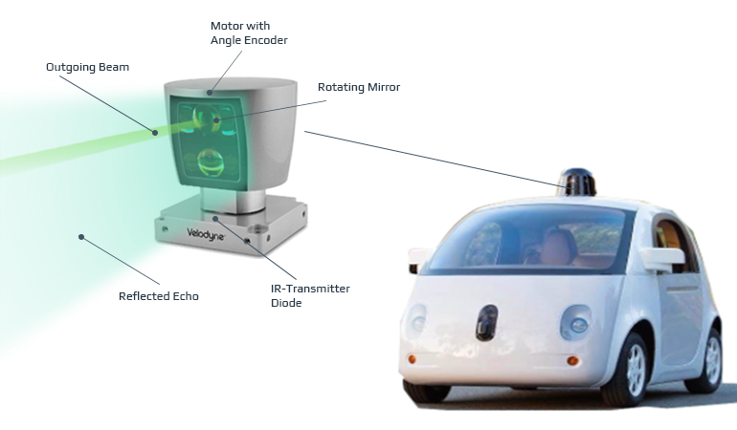

* **Radar**: Tells you the speed and location of moving things around you, especially when it's hard to see.
* **Cameras**: these take pictures and videos that help with finding obstacles, marking lanes, and showing traffic lights.
* **Ultrasonic Sensors**: Find things that are close by, which helps with slow-moving tasks like parking.

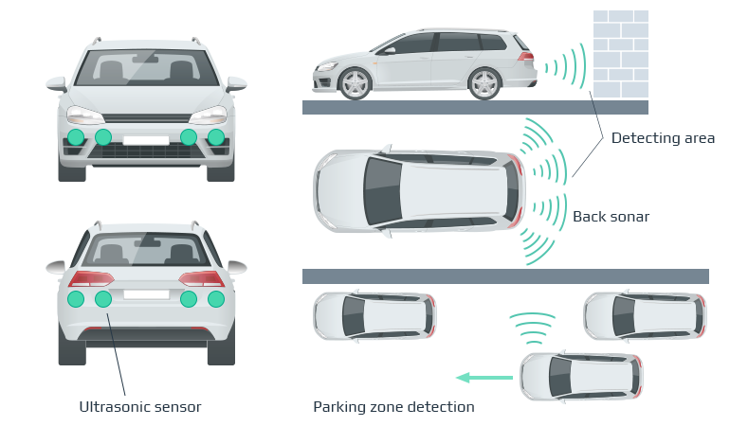

Smart cars will always know where they are and how to get where they need to go if they have GPS.

**Technologies for Data Processing and Communication**

* **Edge Computing** : reduces_latency_for_real-time_decision-making_by_processing_data closer to_the_vehicle.
* **5G_Networks** : It_provides_high-speed,_low-latency_connectivity_required_for constant communication between AVs and the cloud .
* ****Cloud Computing** :** Massive data storage and long-term study of driving habits, behaviour, and trends are made possible this.

**Algorithms and Software Systems**

****Software components:****

**Self-driving cars' brains are software. Real-world algorithms interpret sensor data to make driving judgements. The best path is plotted and actuators are instructed.**

**The ADAS algorithms must lead the vehicle through four autonomous driving stages:**

* ****Perception**: detecting and classifying barriers and neighbourhood parameters**
* ****Localization**: determining its location in the environment.**
* ****Planning**: perception and localisation data are used to design the optimal route from present place to destination.**
* ****Control** : Follow the_trajectory_with_the_right_steering_angle_and_acceleration.**

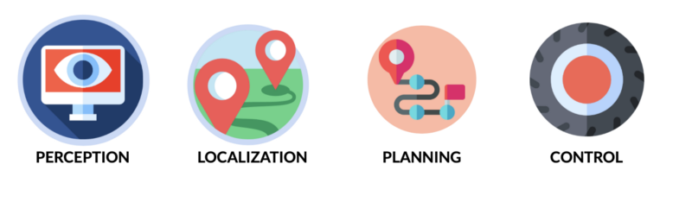

****Convolutional_Neural_Networks_(CNN):_****

**CNNs , _are powerful for feature extraction in images, often used in tasks like object detection and classification. A CNN’s convolutional layer uses small filters (like 3x3 or 5x5) that slide over an image, capturing features such as edges and shapes. With deeper layers, CNNs recognize more complex patterns.**

**The specific CNNs using in self-driving cars are :**

* **_HydraNet_by_Tesla**
* **_ChauffeurNet_by_Google_Waymo**
* **_Nvidia_Self_driving_car**

****Data reduction algorithms for pattern recognition****

**Sensor fusion images must be filtered for superfluous and overlapping data. Repeating patterns help identify object classes. These methods decrease_noise_and unnecessary data_by_fitting_line segments_to_corners _and_circular_arcs_to arc-shaped parts.**

**Algorithms used are:**

* **Principal_Component_Analysis_(_PCA): _reduces_the_dimensionality_of_the_data.**
* **Support_Vector_Machines_(_SVM): for_non-probabilistic_binary_linear_classification.**
* **Histograms_of_Oriented_Gradients_(_HOG):_excellent_for_human_detection**
* **You_Only_Look_Once_(_YOLO):_an_alternative_to_HOG,_it_predicts_each_image section_with_respect_to_the_context_of_the_entire_image.**

****Clustering_algorithms_****

**Classification algorithms may miss items due_to_low-resolution_or_fuzzy pictures, intermittent_or_ sparse_data. Clustering classifies data by its underlying structures to maximise common attributes.**

**Self-driving cars use these clustering algorithms:**

* **K-means**
* **Multi-class neural networks**

****Regression_learning_algorithms****

**Similar to_Doctor_Strange,_these_algorithms_anticipate the_future._Repetitive_features_in_an environment_let_the computer create a_statistical_model_of_the_relationship_between_a_picture and_its_object_position. After computing the association between two variables, regression analysis compares them on multiple scales. It depends on regression line shape, dependent variables, and independent factors. The model_is_learnt_offline_first. The_model_samples_images_for_quick detection_to produce an object's position and certainty while live. Without extra modelling, this approach can be applied to different entities.**

**Self-driving car algorithms are :**

* **Regression random forest**
* **Bayes regression**
* **Regression neural network**

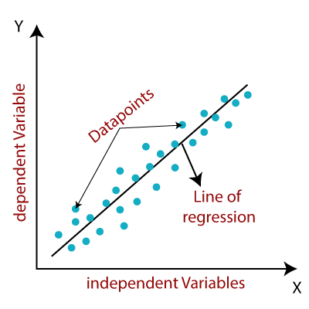

**THE TECHNOLOGY AND IMPLEMENTATION**

**Hardware Components**

It is divided into three main roles:

1. Sensors: Acting like the car’s "eyes," sensors collect information about the surroundings. Different types—such as cameras, LiDAR, and RADAR—work together to create a complete 360-degree view. This combination, known as sensor fusion, merges data at high speeds to form a clear picture of the environment.
2. V2X Communication: Similar to a "mouth and ears," V2X (Vehicle-to-Everything) technology enables the car to communicate with other objects. This includes:

* V2I (Vehicle-to-Infrastructure): Communicating with road infrastructure like traffic lights.
* V2N (Vehicle-to-Network): Connecting to cloud services.
* V2V (Vehicle-to-Vehicle): Sharing data with other vehicles.
* V2P (Vehicle-to-Pedestrian): Interacting with pedestrians.

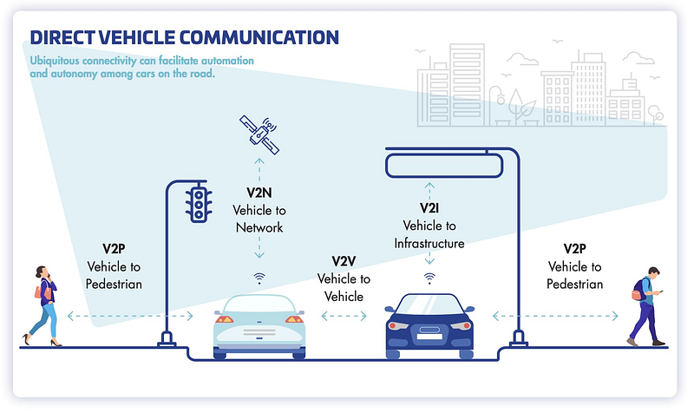

1. Actuators: Functioning like "muscles," actuators carry out physical actions, such as steering, braking, and accelerating, based on signals from the car’s processors.

**Implementation Process**

An IoT requires careful planning towards business goals, enhancement of efficiency improvement, and services. The key steps are as follows:

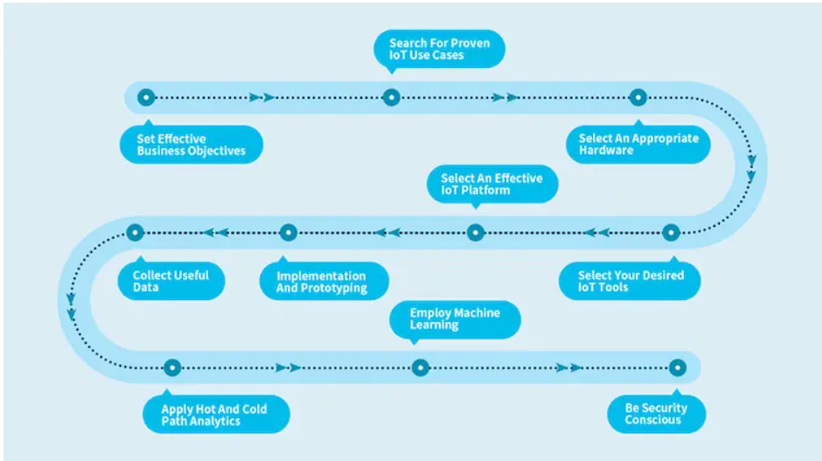

1. Business Objectives: Clearly establish pragmatic IoT goals. Identify some of the short and long-term problems you want to solve, and the best way that could help solve them. This may tell if investment in IoT is worthwhile.

2.Research Proven Use Cases: Study established IoT applications to refine your approach. Examples include predictive maintenance, asset tracking, and environmental monitoring. This helps in identifying and avoiding potential issues.

3. Determine the right hardware Sensors and actuators are needed, like cameras, temperature sensors, and others, depending upon the data to be captured. Be sure that they support IoT protocols like Zigbee or Z-Wave for efficient communication.

4.Select IoT Tools: Select some leading IoT devices that can be connected well with the internet. Those tools and devices help collect, process data, and control to make automation and alerts smart functions.

5. Choose an IoT Platform: Use a platform to manage and operate centrally the various IoT devices and networks. An IoT platform is going to be the foundation for the chosen IoT infrastructure.

6. Implementation and Prototyping: Bring together a team of experts who can design, test, and validate the system. Prototyping allows all components to fit together well and meet your business objectives.

7. Collect Valuable Data: Gather highquality data required for insights and decisions through sensors. Ensure secure storage mechanisms for potentially large volumes of data.

1. Use both Hot and Cold Path Analytics Analyze data both in hot path to affect immediate action and in cold path to guide strategy making. Machine learning can improve both paths.
2. Apply Machine Learning: Use AI along with machine learning to detect patterns, predict, and improve the needs based on real-time and historical data.
3. Security: Install strong security measures that will protect your IOT systems from attacks and cyber breaks, saving your organization and reputation.

**CHALLENGES**

The path of fully autonomous and IoT-integrated vehicles is highly cluttered by appearing with significant challenges. Overcoming these major challenges is very crucial in achieving reliable and secure deployments of such transformative technology. Among the major ones are:

1. Complex Social and Human Interactions: Autonomous vehicles face challenges in interpreting social cues from pedestrians, cyclists, and other drivers—like eye contact or hand gestures—that human drivers rely on. This lack of social awareness makes it challenging for these vehicles to interact safely with unpredictable environments.
2. Weather and Environmental Limitations: Heavy rain, snow, or fog could cause distortion in camera, radar, and LiDAR sensors' operations. As they hinder the ability of autonomous vehicles to see the road markers, signs, and obstacles, the vehicles also fail to check on the safe navigation features. Sensor wipers help with solutions, but adapting to various conditions remains a technical challenge.
3. Map Complexity and Change Continuously: The self-driving car relies entirely on detailed and updated high definition maps for navigation. It is not easy to build and maintain a 3D map, and usually, requires constant updates since road and infrastructure change with time, therefore, the functionality can only be maximal in well-mapped regions.
4. Cyber vulnerability: In fact, with actual integration of IoT, increased connectivity portal leads to various access points for a cyber attack. Severe risks of unauthorized access to control systems that run vehicle control intensify the urgency of cybersecurity, not only for the protection of data inside vehicles but also for vehicle data and passenger safety.
5. Inadequate Infrastructure: Connected and autonomous vehicles depend upon smart infrastructure that includes IoT-enabled traffic signals. However the necessary smart infrastructure is not yet available nearly everywhere, especially in developing regions and their operational fields are hence being limited.
6. Device Discovery and Network Security: Poor IoT device discovery within the network can result in unmonitored and unmanaged devices, which will become an easy target for cyber attacks. Without strong network security measures, such as encryption, secure passwords, and intrusion detection, IoT-enabled vehicles will be open to threats from cyber attacks.
7. Access Control and Regular Update- Device access, as well as regular firmware updates are aspects of IoT security. Unsecured or outdated devices can lead to certain weak points in the system, exposing vehicles to potential hacks and loss of safety. Strong access control, plus the ability to update timely, is imperative.
8. Data Storage and Management: The amount of data collected by autonomous and IoT-enabled vehicles daily can indeed be huge. Managing and processing such huge datasets for research purposes without compromising data privacy becomes challenging. Most the data could require multiple years for analysis; hence, good data management systems are very important.
9. Liability and Legal Accountability: Establishing clear responsibility in cases of accidents involving autonomous vehicles is still a gray area. Determining whether liability falls on the manufacturer, software developer, or passenger is essential to address ethical and legal concerns around autonomous driving.

**INFERENCES**

The integration of IoT into autonomous vehicles is to change the transportation landscape for the safe, adaptive, efficient operation of these vehicles into dense environments. This is while integrating them into IoT connectivity with the sensors and connections with LiDARs, cameras, ultrasonic sensors, etc., all connected to give real-time data about a vehicle's surroundings, hence formulating a whole model of the environment. This model enables the vehicle to make informed decisions about navigation, obstruction avoidance, and route optimization so that it increases safety much more and adapts much better. While providing situational awareness, IoT also enables predictive maintenance, letting all the vehicles run as smoothly with fewer interruptions as possible.

Therefore, real-time data processing becomes very significant for autonomous driving applications because decisions have to be taken on a timescale of milliseconds.

Most interestingly, it's edge computing technologies that allow processing to occur closer to the vehicle-they reduce latency and allow for the prompt response to dynamic situations. However, cloud computing makes it easy to large-scale storage or in-depth analysis, such as identifying driving patterns or continually refining route planning. This has the potential to work toward instantaneous action in critical situations and continue to make autonomous vehicle performance better and better. Despite its advantages, IoT integration in autonomous vehicles also presents significant challenges. Autonomous systems currently struggle with interpreting human social cues—such as hand gestures or eye contact—that are essential for safe navigation in busy or unpredictable environments. Extreme weather conditions further complicate vehicle operation, as snow, rain, or fog can obscure sensors and disrupt visibility. Additionally, autonomous vehicles rely on detailed, up-to-date maps, which are costly and time-consuming to produce and maintain, limiting their effectiveness in poorly mapped areas. Cybersecurity also remains a major concern, as increased connectivity makes vehicles vulnerable to hacking, necessitating stringent security measures.

Finally, the legal and ethical aspects of autonomous vehicles raise complex questions, particularly regarding accident liability. Hence, it decides whether the liability lies with the manufacturer, the software developer or the passenger. In this regard, with the help of IoT major inventions in driverless cars are achieved; still, these technological, environmental, and ethical issues encourage the scientific research and development work. One day, autonomous vehicles may be the key to safety, reliability, and sustainability in transportation modes, and this will enormously benefit smarter cities and a considerably more efficient global transit system.

**FUTURE SCOPE**

The future scope for IoT-enabled autonomous vehicles is gigantic and, coming from these potential evolutions that may transform transportation along with urban infrastructure and the broader wireless scope of IoT, may encompass the possibility of having super-sophisticated sensors onboard along with advanced AI algorithms and communication systems that might be more advanced and can handle complex urban environments with little human intervention. For instance, much-improved next-generation sensors have greater range and accuracy, and much more robust edge computing, which means vehicles can relyably handle challenging weather conditions and interpret complex road scenarios.

With expanding 5G networks, autonomous vehicles will often benefit from ultra-low-latency communication, proving vital for the sharing of real-time data between vehicles (V2V) and with infrastructure (V2I).

This will make it easier for the flow, relieving congestion, and promote safety in the system, as moving vehicles can react immediately to road hazards and traffic signals. Cities may look forward to employing IoT-enabled infrastructure in the future such as smart traffic lights and adaptive road signage. It will create an ecosystem that supports and optimizes autonomous operations. The collective decision of vehicles will be allowed toward better safety and efficiency on roads.

Another area of potential development includes cybersecurity and data privacy in the context of IoT-enabled autonomous systems. With a future where connected automobiles continue to thrive, there is an immediate need for secure, hack-proof systems that protect vehicles from hacking and data breach. Further blockchain technology advancement and advanced encryption protocols will come in handy for complete data integrity as well as secured communication between the vehicle and infrastructure. Cybersecurity in autonomous vehicles will be critical to the formation of public trust and will also be beneficial for regulatory compliance. Lastly, autonomous vehicles would be greatly involved in the development of smart cities and sustainable urban living. For example, through the reduction of traffic accidents and optimum fuel usage as well as emission reductions, the environmental impact of transportation would be diminished by autonomous vehicles. Furthermore, autonomous vehicles would collect data from IoT sensors that could help understand how traffic flows in the city, air quality, and infrastructure needs, which are vital in deciding future urban planning and policy-making. As the technology continues to mature, autonomous vehicles stand ready to become the core enabler of intelligent, eco-friendly cities in shaping a sustainable future of urban mobility.

**APPENDIX**

1. <https://blog.paperspace.com/intro-autonomous-vehicle-theory/>
2. <https://www.mokosmart.com/iot-implementation-guide/>